CSS Message Log

Author: Kay Kasemir, kasemirk@ornl.gov

The CSS Message log design was started by Matthias Clausen, Helge Rickens, Jan Hatje and others at DESY. This document describes its use at the SNS.

Updates:
06/16/2010: Alarm message ‘CURRENT_STATUS’

Overview
The CSS Message log persists various messages that are exchanged via JMS:
- Log messages from CSS and other applications. The Log4j–based CSS ‘CentralLogger’ can log to JMS. Messages include debug messages, information like CSS startup, and error messages.
- Alarm Messages from the JMS topics that the alarm server and clients use to communicate. This includes messages about new alarms, acknowledge requests, and configuration updates.
- Talk messages from the JMS queue that the alarm server uses to annunciate messages.
- Messages sent from a JMSSender command-line client.

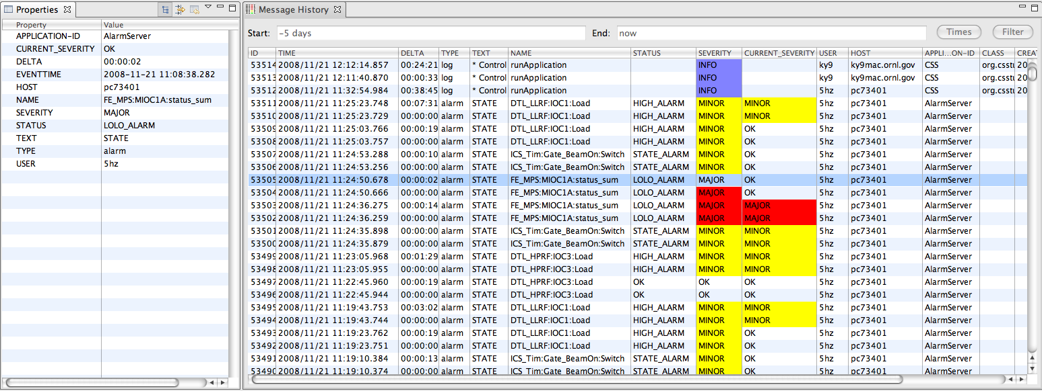
Fig 1: CSS “Message History” browser

jms2rdb
This tool listens to one or more JMS queues (LOG, ALARM_SERVER, ALARM_CLIENT, TALK, WRITE …) and forwards messages to the RDB log.
To build, use the Eclipse product file

org.csstudio.sns.jms2rdb/JMS2RDB.product

To run, you probably want to use a customized copy of the

plugin_customization.ini

in the same plug-in.

Client Access
The “Message History” plug-in for CSS, org.csstudio.sns.msghist, is an interactive message browser that allows CSS users to view messages logged to the RDB (Fig. 1).
Per default it displays all messages for a configurable time range. Messages can be sorted by time, type, user etc. by clicking on the respective table header. In addition, messages can be filtered by any message property. For example, a filter for TYPE equal to “alarm” and “NAME” equal to “%Vac%” would restrict the message history to only alarm log messages from vacuum PVs.
The “Properties” view displays all properties of the currently selected message.

Preference Settings
The preference settings allow selection of the
- RDB URL
- Displayed message properties

Message Types
In principle, messages can have an arbitrary list of properties, i.e. name/value pairs like TEXT=”Test message”. But in reality, messages are only useful when the involved applications understand the messages. The following messages are identified by their TYPE property.

Log Messages
Properties used by log messages:
- TYPE=log
- TEXT: Any text, usually the result of Log4j message format
- SEVERITY=DEBUG, INFO, WARN, ERROR, FATAL: Log4j log level
- CREATETIME, format “yyyy-MM-dd HH:mm:ss.SSS”: Time message created
- EVENTTIME, format “yyyy-MM-dd HH:mm:ss.SSS”: Time of original event
- CLASS: Name of (Java) class were message was created
- NAME: Name of Java method
- FILENAME: Source file
- APPLICATION_ID: Application (CSS, AlarmServer, ..)
- HOST: Host name running the application
- USER: User name

SNS Alarm Server/Client Messages
Properties used by alarm messages. These generally use 3 different topics:
- Topic for messages from the alarm server to clients (e.g. ALARM_SERVER)
- Topic for messages from alarm GUIs to the server (e.g. ALARM_CLIENT)
- Topic for messages from the alarm server (or other programs) to an annunciator (ALARM_TALK)
The first two topics may be the same, i.e. the full server/client exchange is on one topic. Keeping them separate may help when debugging the setup, or later when a per-topic authorization is configured on the JMS server.
The …_TALK topic must be separate because every message sent to it will reach the annunciator.
When logged to the RDB, the original JMS topic that carried the message is lost. Instead, the ‘CONFIG’ property of the logged messages identifies the different alarm configurations.

State update from Alarm Server to clients
This message is sent for each change in the current_severity of the PV or the alarm severity and message.
- TYPE=alarm
- CONFIG=<Name of alarm configuration>
- TEXT=STATE, STATE_ MAINTENANCE
- SEVERITY=OK, MINOR, MAJOR, INVALID: Alarm severity
- STATUS=Alarm message
- VALUE=Value that triggered the alarm transition
- CURRENT_SEVERITY=OK, MINOR, MAJOR, INVALID: Current PV severity
- CURRENT_STATUS=Current PV status
- EVENTTIME, format “yyyy-MM-dd HH:mm:ss.SSS”: Time of original event
- NAME: ProcessVariable
- APPLICATION_ID=AlarmServer
- HOST: Host name running the application
- USER: User name
By default, the message TEXT is STATE, but it might indicate special server modes like STATE_MAINTENANCE while in maintenance mode.

Alarm Server IDLE messages to clients
In the absence of STATE messages from the server, alarm clients would have no idea if there are simply no alarm changes, but the alarm server is still running, or if the server has quit.
If there is no other traffic (STATE messages), the alarm server therefore sends periodic IDLE messages to inform clients that the server is still running.
By default, the server sends these every 10 seconds.
By default, the message TEXT is just IDLE, but it might indicate special server modes like IDLE_MAINTENANCE while in maintenance mode.
- TYPE=alarm
- CONFIG=<Name of alarm configuration>
- TEXT=IDLE, IDLE_MAINTENANCE
- APPLICATION_ID=AlarmServer
- HOST: Host name running the application
- USER: User name

‘Mode’ change request from Alarm Clients to Server
Sent to request a change in ‘Mode’.
- TYPE=alarm
- CONFIG=<Name of alarm configuration>
- TEXT=MODE
- VALUE=NORMAL, MAINTENANCE

Enablement update from Alarm Server to clients
Sent in response to dynamic, filter-based enablement performed by the server. When a client enables/disables a PV via a configuration change, this results in a configuration update event as shown below.
- TYPE=alarm
- CONFIG=<Name of alarm configuration>
- TEXT=ENABLE, DISABLE
- STATUS=Alarm message
- NAME: ProcessVariable that is enabled or disabled
- APPLICATION_ID=AlarmServer
- HOST: Host name running the application
- USER: User name

Acknowledge request from client to Alarm Server
When clients request an acknowledgement, the server will usually reply with a state update for the affected PV.
- TYPE=alarm
- CONFIG=<Name of alarm configuration>
- TEXT=ACK, UN-ACK: Request acknowledge or un-acknowledge
- NAME: ProcessVariable
- APPLICATION_ID=CSS
- HOST: Host name running the application
- USER: User name

Configuration update client to Alarm Server and other clients
- TYPE=alarm
- CONFIG=<Name of alarm configuration>
- TEXT=CONFIG
- NAME: Path to ProcessVariable or empty for change not limited to a PV
- APPLICATION_ID=CSS
- HOST: Host name running the application
- USER: User name

Annunciation from AlarmServer
- TYPE=talk
- CONFIG=<Name of alarm configuration>
- SEVERITY=OK, MINOR, MAJOR, INVALID: Alarm severity (optional)
- TEXT=Text to annunciate
- APPLICATION_ID=AlarmServer
- HOST: Host name running the application
- USER: User name

EDM ‘write’ log
EDM can log PV puts to a 'write' log, see EDM manual for details:

http://ics-web.sns.ornl.gov/edm/edmUserManual/index.html#pv-put-logging

Properties that could be used to log ‘puts’ i.e. writes to a PV from EDM
- TYPE=write
- NAME: Process variable's name
- VALUE: Process variable's new value
- TEXT: Holds the text “pvname=pvvalue”
- OLDVALUE: Process variable's original value
- HOST: Host name running the application
- USER: User name
- SSH: Holds the ssh string
- DSP: Holds the display string
- APPLICATION_ID=EDM

To test, first try to run

JMSSender -url tcp://ics-srv02.sns.ornl.gov:61616 –topic WRITE
-type write -edm_mode

then paste lines like the one below to its std-input:

user="fred" host="ics-srv02" ssh="::ffff:160.91.233.3 54425
::ffff:160.91.230.38 22” dsp="localhost:16.0” name="RFQ_Vac:Pump1:Pressure"
old="1.000000" new="2.000000"

If that turns into a corresponding JMS message, wrap the JMSSender command used in the above test into a shell script 'edm_write_logger.sh' and use that as the EDM put logger:

export EDMPUTLOGGER=edm_write_logger.sh

Basic Table Layout
To allow this variety of messages, the JMS messages use a “Map” which can contain nearly arbitrary properties as name/value strings, and the RDB table layout reflects this.

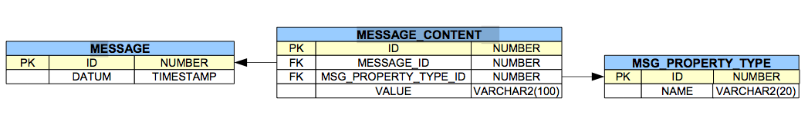
Fig 2: Basic RDB Table Schema for Message Log

Each message starts with a time-stamped entry in the MESSAGE table. The properties of a message (TEXT, USER, …) are then added as columns to the MESSAGE_CONTENT. The available property names are in the MSG_PROPERTY_TYPE table.

Site-specific Table Layout Adjustments
As obvious from the message type descriptions, every message has a TYPE property. Alarm and log messages also have a SEVERITY property. To allow efficient access to for example all messages with TYPE=’alarm’ or SEVERITY=’ERROR’, sites are allowed to add property columns to the MESSAGE table.
Client tools are ideally written such that they use for example JDBC database metadata to determine which columns in addition to the default “id” and “datum” are found in the MESSAGE table.

For SNS, the MESSAGE table includes properties
- TYPE
- NAME
- SEVERITY

As an example, filtering on ‘alarm’ messages is thus possible via a direct

SELECT .. FROM MESSAGE WHERE TYPE=’alarm’ ..

Instead of having to search the MESSAGE_CONTENT entries of each message for a TYPE property with value ‘alarm’.

RDB Setup
The source code for the plug-in org.csstudio.sns.jms2rdb contains a “dbd” directory with database creation files for MySQL and Oracle.

